  - Department of Computer Science and Engineering
  - National Institute of Technology Srinagar
Hazratbal, Srinagar, Jammu and Kashmir - 190006, India

  - AI LAB FILE
AI Lab
Submitted by
Sahil Madaan
2023BCSE048


III B.Tech. CSE (6th Semester - Section “B”)

Submitted to
Dr. Tawseef Ayoub Shaikh

Department of Computer Science and Engineering
National Institute of Technology Srinagar
Hazratbal, Srinagar, Jammu and Kashmir - 190006, India.

OUTPUT:

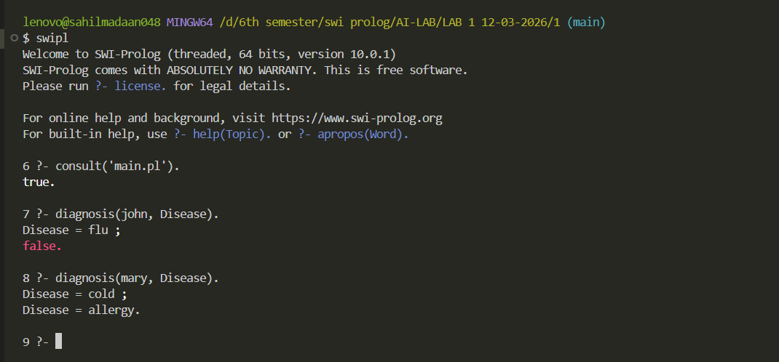

Lab 1

- Medical Diagnosis Expert System using Prolog
Write a Prolog program to diagnose diseases such as flu, cold, and allergy based on
given symptoms.
Symptoms:
Flu= fever, cough, headache
Cold=sneezing ,runny nose
Allergy= sneezing, fever

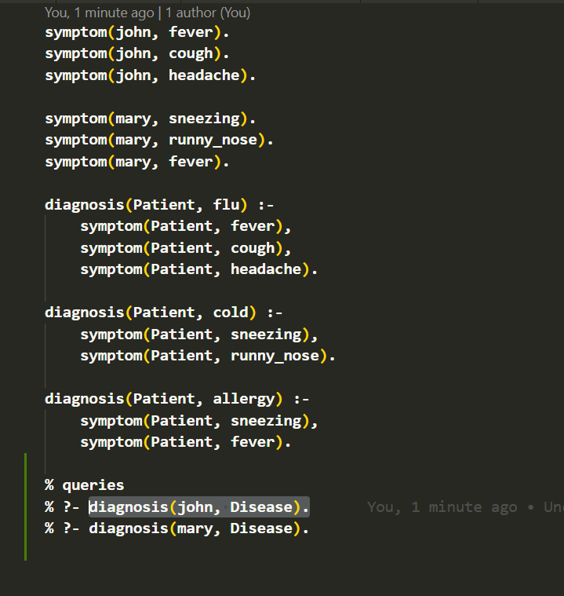

OUTPUT:
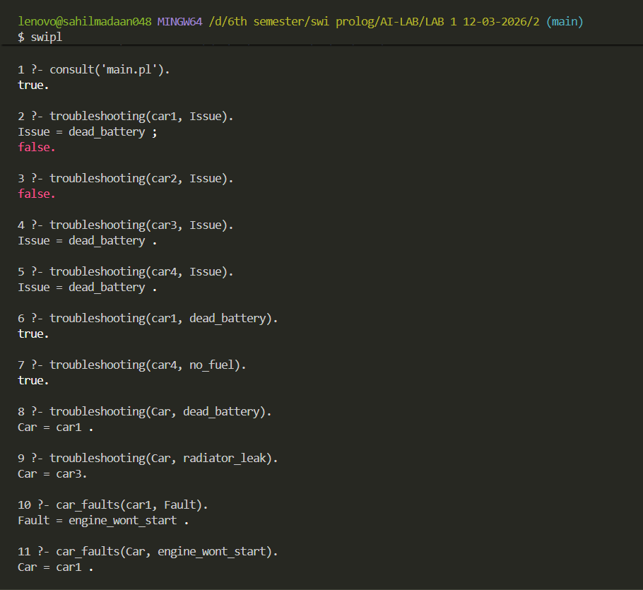

Lab 1
- Car Troubleshooting Expert System in Prolog
Write a Prolog program to identify car faults from observed problems and suggest
suitable repairs.
Car faults:
Dead_battery= engine_wont_start
Blown_head_gasket=overheating,coolant_low,whitesmoke
Radiator_leak=overheating,coolant_low
No_fuel=engine_wont_start, fuel_guage_empty

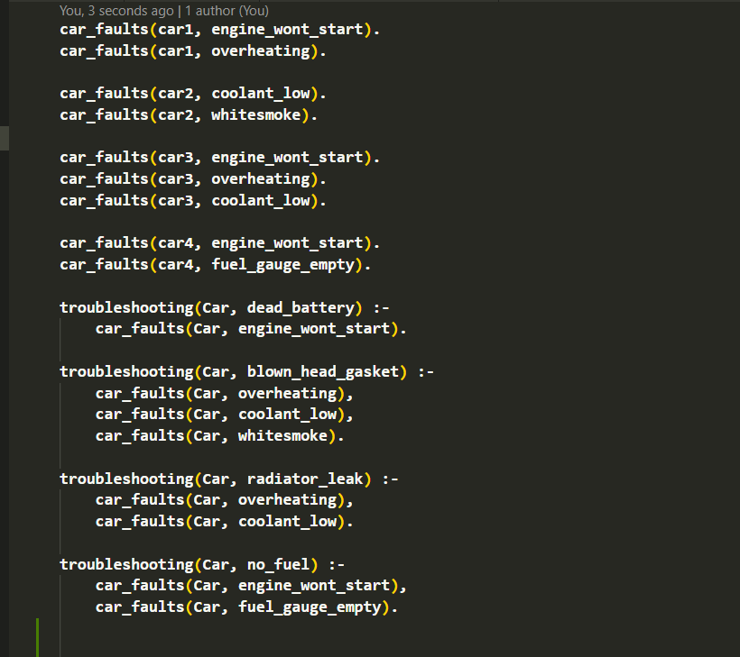

OUTPUT:

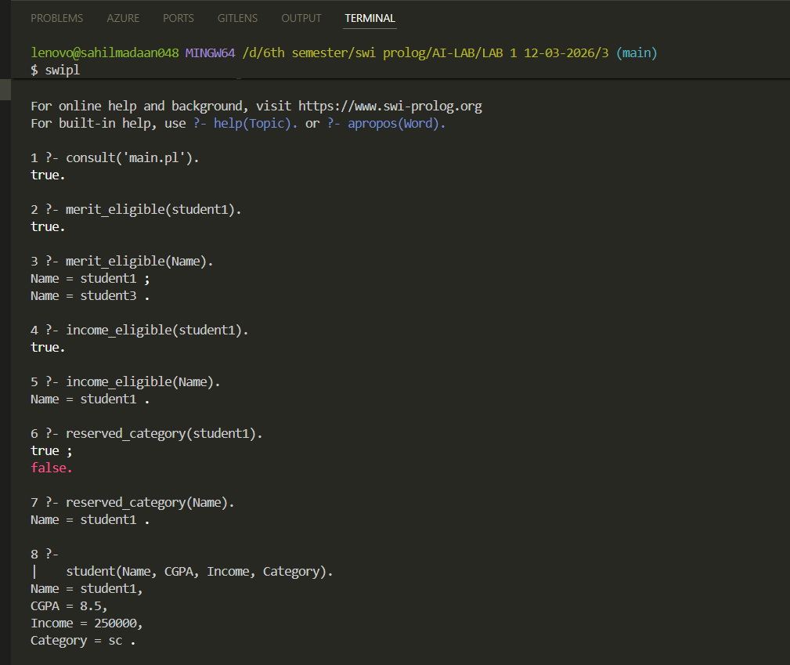

Lab 1
- Student Scholarship Eligibility Checker in Prolog
Write a Prolog program to determine student eligibility for different scholarship types
based on CGPA, income, and category.
Rules for scholarship:
merit_eligible(Name) :- student(Name, CGPA, _, _), CGPA >= 8.0.
income_eligible(Name) :- student(Name, _, Income, _), Income =< 300000.
reserved_category(Name) :-student(Name, _, _, Cat),member(Cat, [sc, st, obc])

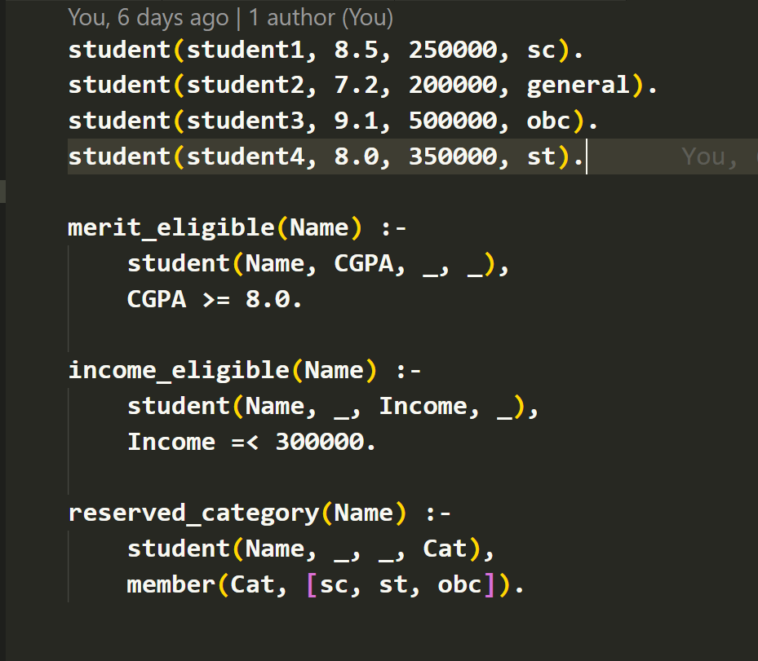

OUTPUT:

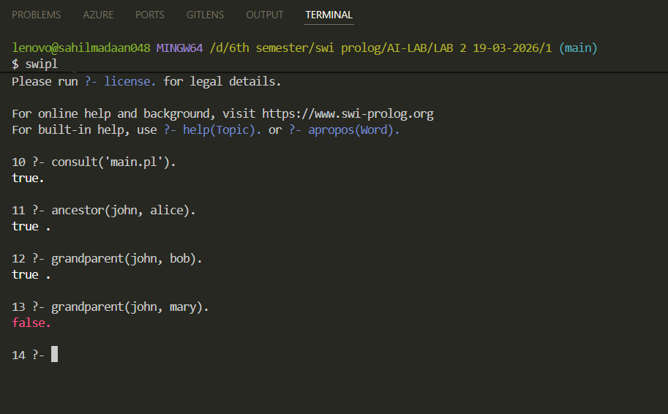

Lab 2
- Extended Family Tree with Ancestor
Write a program in Prolog that defines a knowledge base representing extended family tree with atleast two generations.
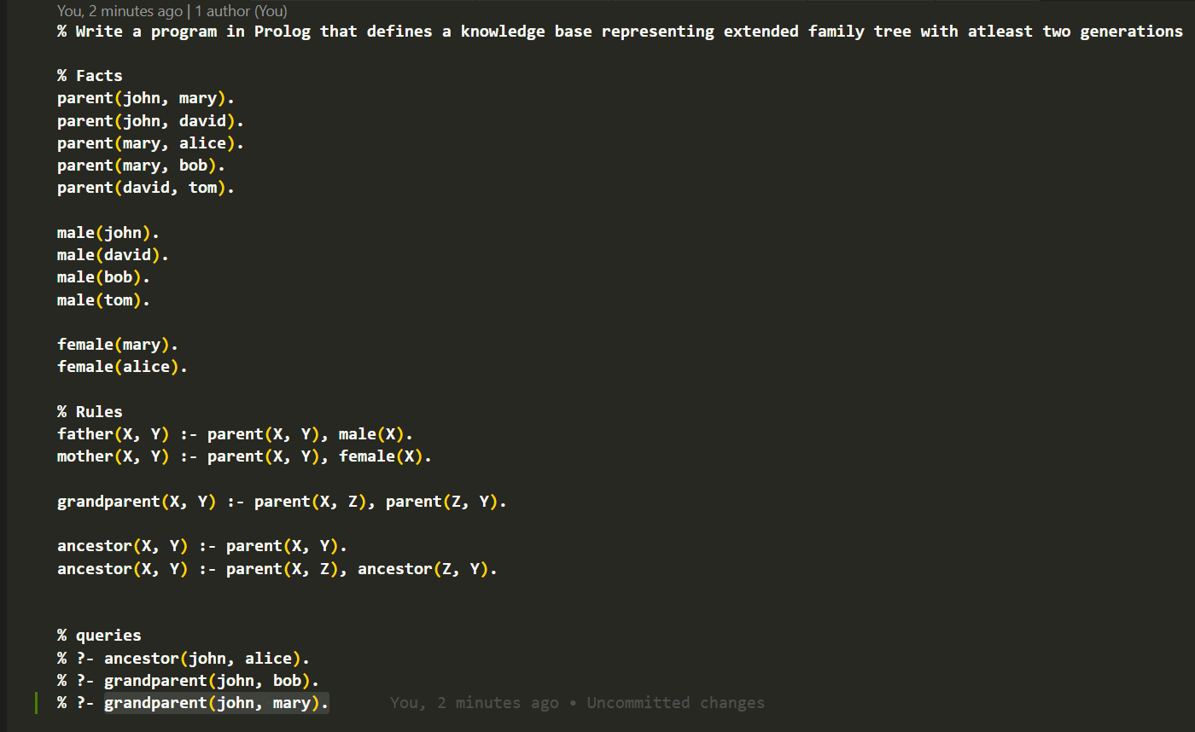

OUTPUT:
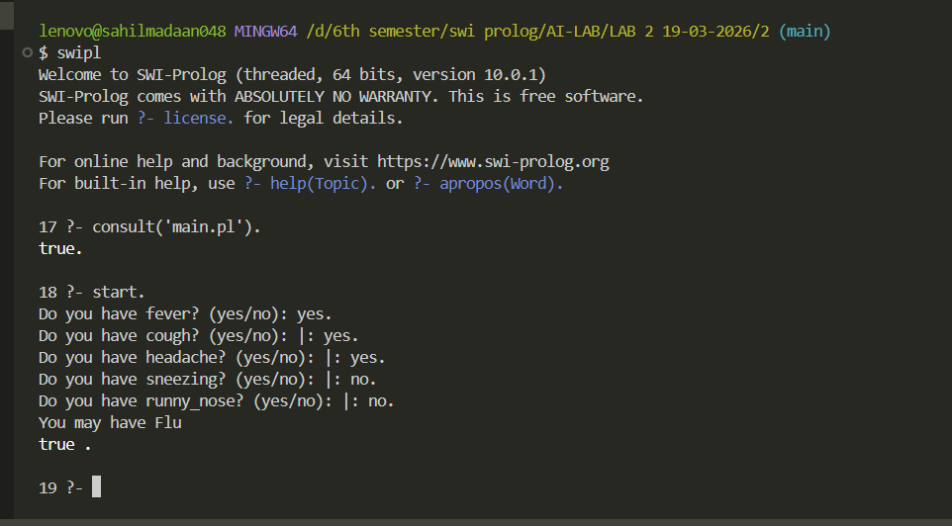

Lab 2
- Interactive Chatbot using read/write
Write a program in Prolog to develop an interactive consultation system that diagnoses common diseases based on symptoms entered
by the user
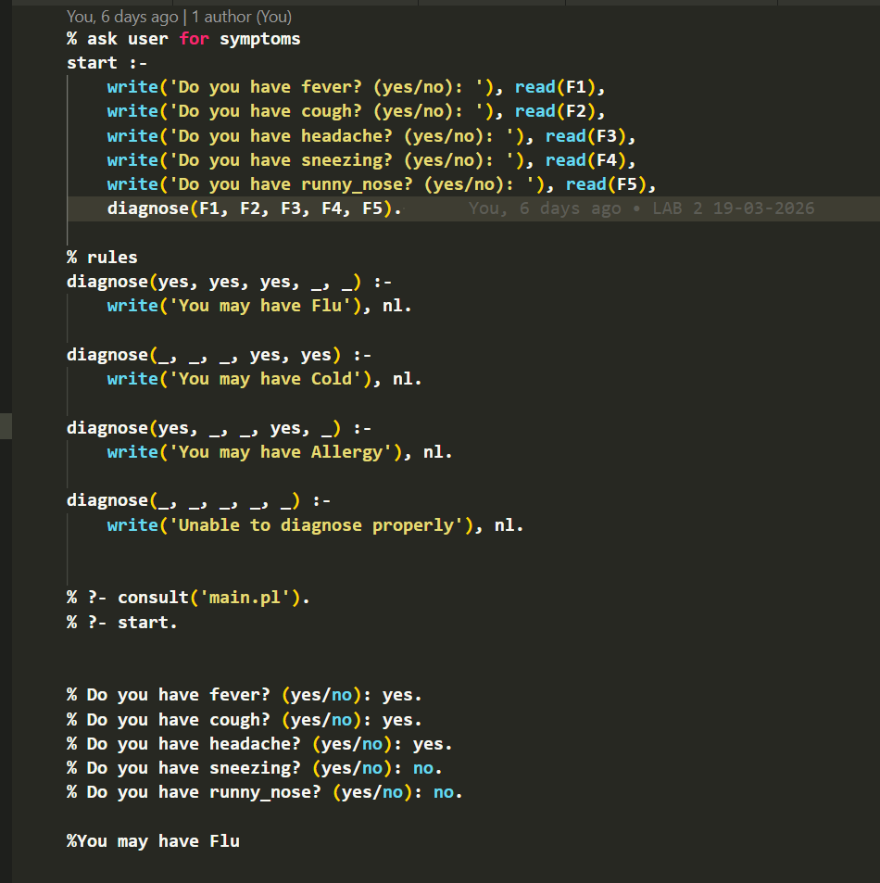

OUTPUT:
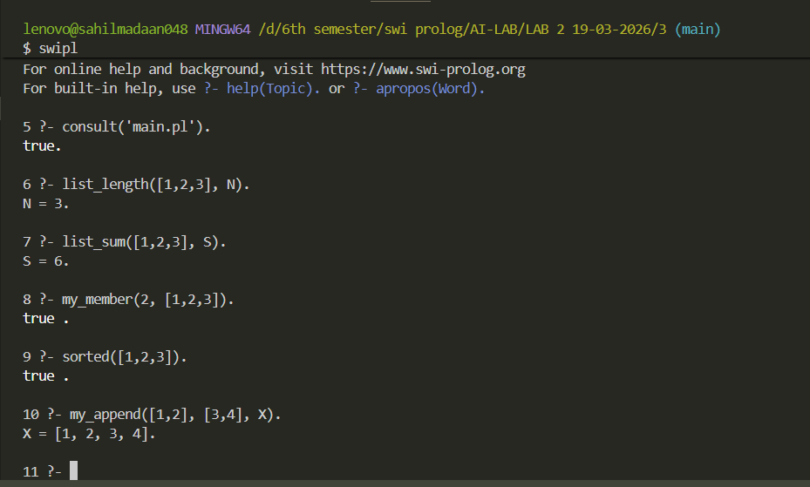
4’6

Lab 2
- List Operations
Write Prolog program to perform the following operations on lists. Use recursion wherever applicable: length of list, sum of elements,
membership check, check if list is sorted, append & concatenate

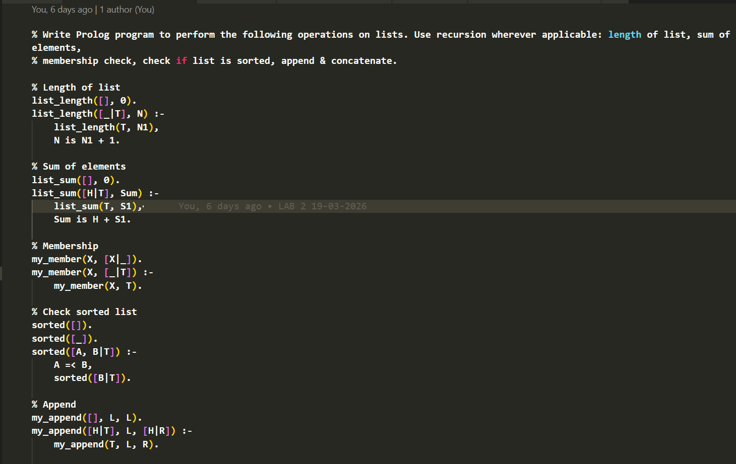

OUTPUT:

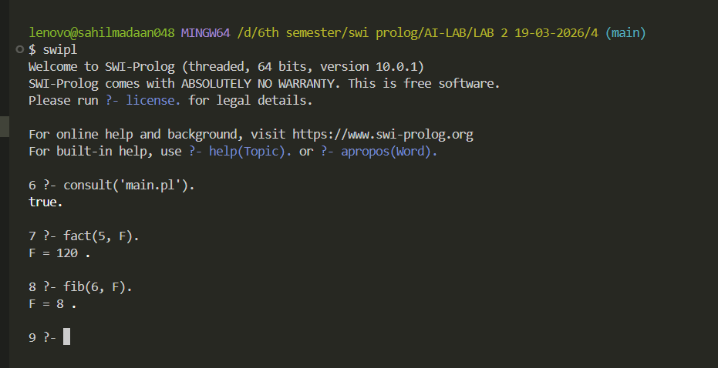

Lab 2
- Arithmetic – Factorial and Fibonacci
Write a program in Prolog that computes factorial of a number and nth Fibonacci number.
